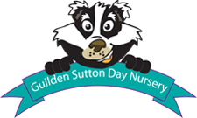
Washing Up Bowl Science (Water Play)
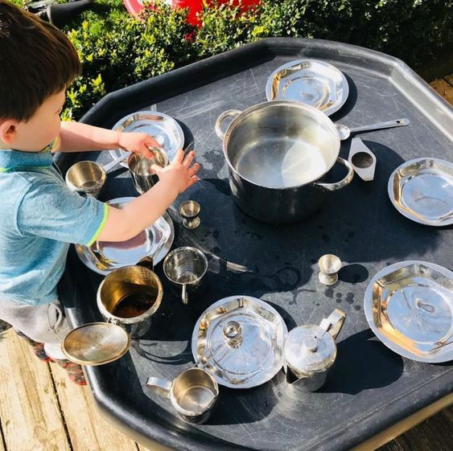
Find a bowl and selection of containers suitable for using in water pouring activities. These might include pans, jugs, empty milk containers, plastic mugs, etc. Ensure the water is at a safe temperature. By using a washing up bowl, or a large mixing bowl you will be able to keep the quantity of water down to a minimum to avoid wastage. The children can scoop the water from the bowl into the receptacles.
Let the children empty and fill with the water.
Key Questions:
Which container holds the most? How many cups of water go into the pan? How many does it take to fill an egg cup?
Key words:
empty pour disperse solid liquid vanish absorb compare sink float fill drip droplet
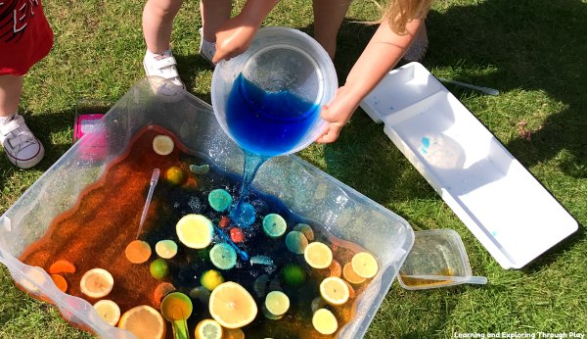
What happens when?:
Can you mix food colouring in? Or some chopped fruit? Does it smell different? Did it float on the surface before you stirred it around?
You could add a teaspoon of washing up liquid to the water. What will happen? Does it disappear and disperse when you mix it? Give them different utensils to use.
Look at the spoons, ladles, whisks, salad servers, spatulas, etc. Think about what the children could use in their water experiments. Not only are they carrying out experiments, they are using key motor skills. You could also talk about what the utensils are made of e.g. wood, plastic, silicon, metal and what colours they are.
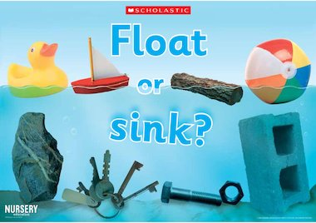
Challenge!
Try some floating and sinking activities. This doesn’t just have to be objects. You could see if sprinkled pepper floats on the surface, or salt, shampoo, vinegar, flour, etc. Then you could try coins, a Lego brick, a lolly stick, a key, etc. You might even build a little boat, or improvise with an empty butter tub and see how much cargo it can hold until it sinks. Can you count the items? Encourage them to think about size, shape and weight of the objects before they place them in the water. Once you have placed the objects in the water talk with your child if their predictions were correct. Children can learn about making predictions and experimenting.
Role Play
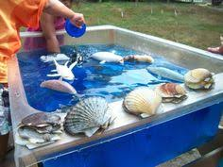
The washing up bowl also makes a great under the ocean scene. You could add shells, a diver, plastic fish, etc. and make up a deep sea adventure. Your child may have a favourite story or film they could us to make their story come to life.

